# **Data documentation**

In our pursuit of understanding the landscape of Twitter accounts within the realm of cryptocurrency, we embarked on a comprehensive analysis utilizing targeted keywords related to 'cryptocurrency' The objective is to unravel the intricacies of user interactions and relationships within the cryptocurrency community. By strategically employing search queries focusing on the crypto domain, we aim to extract valuable insights into the preferences, discussions, and trends among users actively engaged in this dynamic field.

Our methodology involves filtering tweets based on criteria such as the number of retweets and likes, ensuring that the collected data is reflective of content that has resonated significantly within the crypto community. Through this process, we intend to identify key influencers and thought leaders whose tweets carry substantial influence and resonance in the Twitter-sphere.

As we navigate through this exploration, the subsequent sections will provide a detailed examination of the gathered data, shedding light on the profiles, behaviors, and relationships that define the cryptocurrency discourse on Twitter.

**Crawled tweets**

Fields:

| Name | Data Type | Description |
| --- | --- | --- |
| original_tweet | Dictionary | Information on the tweet, containing some later fields. |
| bookmark_count | Integer | Number of times the tweet has been bookmarked. |
| created_at | Date time | The timestamp when the tweet was created in a human-readable format. |
| conversation_id_str | String | A unique identifier representing the conversation to which the tweet |
| display_text_range | List | Range of characters in the full text that should be displayed. |
| entities | Dictionary | Various entities (mentions, media, hashtags, etc.) in the tweet. |
| media | List | Information about media content (including images) in the tweet |
| user_mentions | List | Mentions of other Twitter users in the tweet. |
| urls | List |
| hashtags | List |
| symbols | List |
| extended_entities | Dictionary | Extended information about entities, particularly media. |
| favorite_count | Integer | Number of favorites (likes) the tweet received. |
| favorited | Boolean | Indicates whether the authenticated user (the user making the request) has favorited (liked) this tweet |
| full_text | String | The actual text content of the tweet. |
| is_quote_status | Boolean | Indicates whether the tweet is quoting another tweet. |
| lang | String | Language of the tweet. |
| possibly_sensitive | Boolean | Indicates whether the user's content may be sensitive. |
| possibly_sensitive_editable | Boolean | Indicates whether the sensitivity status of the tweet is editable. |
| quote_count | Integer | Number of times the tweet has been quoted. |
| reply_count | Integer | Number of replies to the tweet. |
| retweet_count | Integer | Number of times the tweet has been retweeted. |
| retweeted | Boolean | Indicates whether the authenticated user (the user making the request) has retweeted this tweet. |
| user_id_str | String | A unique identifier representing the user who posted the tweet. |
| id_str | String | A unique identifier representing the tweet. |
| id | String | The unique identifier for the tweet. |
| created_on | Date time | Date and time the tweet was created. |
| date | String | The date the tweet was posted. |
| author | Dictionary (User) | Author of the tweet, details:   * ID: Integer * Username: String * Name: String * Verification Status: Boolean |
| original_user | Dictionary | Information about the original user who authored the tweet. This includes various details about the user's profile, activity, and settings on Twitter. |
| description | String | The user's description or bio provided in their Twitter profile. |
| bio | String | Provides a brief summary or information about the user's interests, profession Twitter profile. |
| favourites_count | Integer | Number of tweets the user has marked as favorites. |
| followers_count | Integer | Count of fast followers for the user. |
| friends_count | Integer | This metric represents the number of accounts that the user has chosen to follow to receive their tweets in their own timeline. |
| media_count | Integer | Count of media items, indicating the number of media files the user has shared on their profile. |
| name | String | The user's name. This is the display name associated with the Twitter account, and it is the name that is shown on the user's profile. |
| statuses_count | Integer | Total number of tweets posted by the user. |
| is_retweet | Boolean | Indicates whether the tweet is a retweet. |
| text | String | The text content of the tweet. This field contains the actual message or information that the user has posted in their tweet. |
| tweet_body | String | The content of the tweet, often referred to as the "tweet body." This field contains the text message or information that the user has posted in their tweet. |
| is_quoted | Boolean | Indicates whether the tweet is quoting another tweet. |
| quoted_tweet | Dictionary | Information about the quoted tweet if applicable. |
| is_reply | Boolean | Indicates whether the tweet is a reply. |
| is_sensitive | Boolean | Indicates whether the tweet contains sensitive content. |
| replied_to | Dictionary | Information about the tweet to which the current tweet is a reply. |
| vibe | String | Descriptive term for the overall feel or tone of the tweet. |
| views | Integer | Number of views the tweet has received. |
| likes | Integer | Number of likes the tweet has received. |
| place | Dictionary | Information about the place associated with the tweet, if available. |
| source | String | The platform or device used to post the tweet. |
| audio_space_id | String | Identifier for audio spaces, if applicable. |
| voice_info | Dictionary | Information related to voice content, if applicable. |
| pool | Dictionary | Viewer pool information, if available. |
| community_note | String | Additional notes or information related to any associated community. |
| community | Dictionary | Information about any associated community or group. |
| threads | Dictionaries | Information about tweet threads. |
| comments | List | Comments or replies to the tweet. |

**Example**

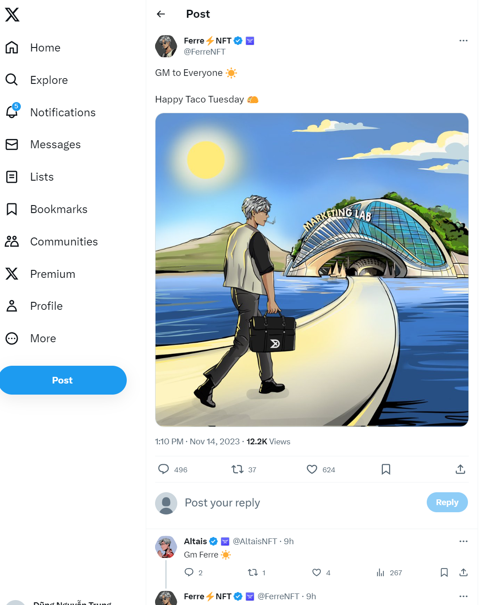

**{**

**"original_tweet": {**

**"bookmark_count": 0,**

**"bookmarked": false,**

**"created_at": "Tue Nov 14 06:10:33 +0000 2023",**

**"conversation_id_str": "1724308818794774771",**

**"display_text_range": [**

**0,**

**39**

**],**

**"entities": {**

**"media": [**

**{**

**"display_url": "pic.twitter.com/lwojk7WLJ4",**

**"expanded_url": "https://twitter.com/FerreNFT/status/1724308818794774771/photo/1",**

**"id_str": "1724308815917494273",**

**"indices": [**

**40,**

**63**

**],**

**"media_key": "3_1724308815917494273",**

**"media_url_https": "https://pbs.twimg.com/media/F-35u3fWMAEv2bB.jpg",**

**"type": "photo",**

**"url": "https://t.co/lwojk7WLJ4",**

**"ext_media_availability": {**

**"status": "Available"**

**},**

**"features": {**

**"large": {**

**"faces": []**

**},**

**"medium": {**

**"faces": []**

**},**

**"small": {**

**"faces": []**

**},**

**"orig": {**

**"faces": []**

**}**

**},**

**"sizes": {**

**"large": {**

**"h": 2048,**

**"w": 2048,**

**"resize": "fit"**

**},**

**"medium": {**

**"h": 1200,**

**"w": 1200,**

**"resize": "fit"**

**},**

**"small": {**

**"h": 680,**

**"w": 680,**

**"resize": "fit"**

**},**

**"thumb": {**

**"h": 150,**

**"w": 150,**

**"resize": "crop"**

**}**

**},**

**"original_info": {**

**"height": 2048,**

**"width": 2048,**

**"focus_rects": [**

**{**

**"x": 0,**

**"y": 92,**

**"w": 2048,**

**"h": 1147**

**},**

**{**

**"x": 0,**

**"y": 0,**

**"w": 2048,**

**"h": 2048**

**},**

**{**

**"x": 252,**

**"y": 0,**

**"w": 1796,**

**"h": 2048**

**},**

**{**

**"x": 768,**

**"y": 0,**

**"w": 1024,**

**"h": 2048**

**},**

**{**

**"x": 0,**

**"y": 0,**

**"w": 2048,**

**"h": 2048**

**}**

**]**

**}**

**}**

**],**

**"user_mentions": [],**

**"urls": [],**

**"hashtags": [],**

**"symbols": []**

**},**

**"extended_entities": {**

**"media": [**

**{**

**"display_url": "pic.twitter.com/lwojk7WLJ4",**

**"expanded_url": "https://twitter.com/FerreNFT/status/1724308818794774771/photo/1",**

**"id_str": "1724308815917494273",**

**"indices": [**

**40,**

**63**

**],**

**"media_key": "3_1724308815917494273",**

**"media_url_https": "https://pbs.twimg.com/media/F-35u3fWMAEv2bB.jpg",**

**"type": "photo",**

**"url": "https://t.co/lwojk7WLJ4",**

**"ext_media_availability": {**

**"status": "Available"**

**},**

**"features": {**

**"large": {**

**"faces": []**

**},**

**"medium": {**

**"faces": []**

**},**

**"small": {**

**"faces": []**

**},**

**"orig": {**

**"faces": []**

**}**

**},**

**"sizes": {**

**"large": {**

**"h": 2048,**

**"w": 2048,**

**"resize": "fit"**

**},**

**"medium": {**

**"h": 1200,**

**"w": 1200,**

**"resize": "fit"**

**},**

**"small": {**

**"h": 680,**

**"w": 680,**

**"resize": "fit"**

**},**

**"thumb": {**

**"h": 150,**

**"w": 150,**

**"resize": "crop"**

**}**

**},**

**"original_info": {**

**"height": 2048,**

**"width": 2048,**

**"focus_rects": [**

**{**

**"x": 0,**

**"y": 92,**

**"w": 2048,**

**"h": 1147**

**},**

**{**

**"x": 0,**

**"y": 0,**

**"w": 2048,**

**"h": 2048**

**},**

**{**

**"x": 252,**

**"y": 0,**

**"w": 1796,**

**"h": 2048**

**},**

**{**

**"x": 768,**

**"y": 0,**

**"w": 1024,**

**"h": 2048**

**},**

**{**

**"x": 0,**

**"y": 0,**

**"w": 2048,**

**"h": 2048**

**}**

**]**

**}**

**}**

**]**

**},**

**"favorite_count": 559,**

**"favorited": false,**

**"full_text": "GM to Everyone ☀️\n\nHappy Taco Tuesday 🌮 https://t.co/lwojk7WLJ4",**

**"is_quote_status": false,**

**"lang": "en",**

**"possibly_sensitive": false,**

**"possibly_sensitive_editable": true,**

**"quote_count": 4,**

**"reply_count": 449,**

**"retweet_count": 29,**

**"retweeted": false,**

**"user_id_str": "1398988286597734403",**

**"id_str": "1724308818794774771"**

**},**

**"id": "1724308818794774771",**

**"created_on": "2023-11-14 06:10:33+00:00",**

**"date": "2023-11-14 06:10:33+00:00",**

**"author": {**

**"original_user": {**

**"can_dm": true,**

**"can_media_tag": true,**

**"created_at": "Sun May 30 13:03:04 +0000 2021",**

**"default_profile": true,**

**"default_profile_image": false,**

**"description": "Marketing & Community Building | Advisor | Dm For Promo & Campaigns | 🌐 | Advisor | @CriminalKidsNFT",**

**"entities": {**

**"description": {**

**"urls": []**

**}**

**},**

**"fast_followers_count": 0,**

**"favourites_count": 96257,**

**"followers_count": 143282,**

**"friends_count": 67227,**

**"has_custom_timelines": true,**

**"is_translator": false,**

**"listed_count": 143,**

**"location": "",**

**"media_count": 2083,**

**"name": "Ferre⚡NFT",**

**"normal_followers_count": 143282,**

**"pinned_tweet_ids_str": [],**

**"possibly_sensitive": false,**

**"profile_banner_url": "https://pbs.twimg.com/profile_banners/1398988286597734403/1698330821",**

**"profile_image_url_https": "https://pbs.twimg.com/profile_images/1671821409301954563/snzRufXH_normal.png",**

**"profile_interstitial_type": "",**

**"screen_name": "FerreNFT",**

**"statuses_count": 63969,**

**"translator_type": "none",**

**"verified": false,**

**"want_retweets": false,**

**"withheld_in_countries": []**

**},**

**"id": 1398988286597734403,**

**"rest_id": 1398988286597734403,**

**"created_at": "2021-05-30 13:03:04+00:00",**

**"date": "2021-05-30 13:03:04+00:00",**

**"entities": {**

**"description": {**

**"urls": []**

**}**

**},**

**"description": "Marketing & Community Building | Advisor | Dm For Promo & Campaigns | 🌐 | Advisor | @CriminalKidsNFT",**

**"bio": "Marketing & Community Building | Advisor | Dm For Promo & Campaigns | 🌐 | Advisor | @CriminalKidsNFT",**

**"fast_followers_count": null,**

**"favourites_count": 96257,**

**"followers_count": 143282,**

**"friends_count": 67227,**

**"has_custom_timelines": true,**

**"is_translator": null,**

**"listed_count": 143,**

**"location": null,**

**"media_count": 2083,**

**"name": "Ferre⚡NFT",**

**"normal_followers_count": 143282,**

**"profile_banner_url": "https://pbs.twimg.com/profile_banners/1398988286597734403/1698330821",**

**"profile_image_url_https": "https://pbs.twimg.com/profile_images/1671821409301954563/snzRufXH_normal.png",**

**"profile_interstitial_type": null,**

**"protected": null,**

**"screen_name": "FerreNFT",**

**"username": "FerreNFT",**

**"statuses_count": 63969,**

**"translator_type": "none",**

**"verified": true,**

**"can_dm": true,**

**"following": false,**

**"community_role": null,**

**"notifications_enabled": false,**

**"notifications": false,**

**"possibly_sensitive": null,**

**"pinned_tweets": null,**

**"profile_url": "https://twitter.com/FerreNFT"**

**},**

**"is_retweet": false,**

**"retweeted_tweet": null,**

**"rich_text": null,**

**"text": "GM to Everyone ☀️\n\nHappy Taco Tuesday 🌮 https://t.co/lwojk7WLJ4",**

**"tweet_body": "GM to Everyone ☀️\n\nHappy Taco Tuesday 🌮 https://t.co/lwojk7WLJ4",**

**"is_quoted": false,**

**"quoted_tweet": null,**

**"is_reply": false,**

**"is_sensitive": false,**

**"reply_counts": 449,**

**"quote_counts": 4,**

**"replied_to": null,**

**"bookmark_count": 0,**

**"vibe": "",**

**"views": "8037",**

**"language": "en",**

**"likes": 559,**

**"place": null,**

**"retweet_counts": 29,**

**"source": "Twitter for Android",**

**"audio_space_id": null,**

**"voice_info": null,**

**"media": [**

**{**

**"display_url": "pic.twitter.com/lwojk7WLJ4",**

**"expanded_url": "https://twitter.com/FerreNFT/status/1724308818794774771/photo/1",**

**"id": "1724308815917494273",**

**"alt_text": null,**

**"indices": [**

**40,**

**63**

**],**

**"media_url_https": "https://pbs.twimg.com/media/F-35u3fWMAEv2bB.jpg",**

**"direct_url": "https://pbs.twimg.com/media/F-35u3fWMAEv2bB.jpg",**

**"type": "photo",**

**"url": "https://t.co/lwojk7WLJ4",**

**"features": {**

**"large": {**

**"faces": []**

**},**

**"medium": {**

**"faces": []**

**},**

**"small": {**

**"faces": []**

**},**

**"orig": {**

**"faces": []**

**}**

**},**

**"media_key": "3_1724308815917494273",**

**"mediaStats": null,**

**"sizes": [**

**{**

**"name": "large",**

**"width": 2048,**

**"height": 2048,**

**"resize": "fit"**

**},**

**{**

**"name": "medium",**

**"width": 1200,**

**"height": 1200,**

**"resize": "fit"**

**},**

**{**

**"name": "small",**

**"width": 680,**

**"height": 680,**

**"resize": "fit"**

**},**

**{**

**"name": "thumb",**

**"width": 150,**

**"height": 150,**

**"resize": "crop"**

**}**

**],**

**"original_info": {**

**"height": 2048,**

**"width": 2048,**

**"focus_rects": [**

**{**

**"x": 0,**

**"y": 92,**

**"w": 2048,**

**"h": 1147**

**},**

**{**

**"x": 0,**

**"y": 0,**

**"w": 2048,**

**"h": 2048**

**},**

**{**

**"x": 252,**

**"y": 0,**

**"w": 1796,**

**"h": 2048**

**},**

**{**

**"x": 768,**

**"y": 0,**

**"w": 1024,**

**"h": 2048**

**},**

**{**

**"x": 0,**

**"y": 0,**

**"w": 2048,**

**"h": 2048**

**}**

**]**

**},**

**"file_format": "jpg",**

**"streams": []**

**}**

**],**

**"pool": null,**

**"user_mentions": [],**

**"urls": [],**

**"hashtags": [],**

**"symbols": [],**

**"community_note": null,**

**"community": null,**

**"url": "https://twitter.com/FerreNFT/status/1724308818794774771",**

**"threads": [],**

**"comments": []**

**}**